**A STUDY ON PROFITIABILITY ANALYSIS OF AGRICULTURAL DEVELOPMENT BANK LIMITED**

**A Project Work Report**

**By**

**Asmita Luitel**

**Symbol no.:703020042**

**Tu Reg no: 7-2-302-368-2020**

**Lumbini Baniya Campus**

**Submitted to**

The Faculty of Management

Tribhuvan University

Kathmandu

In Partial Fulfillment of the Requirements for the Degree of

BACHELOR OF BUSINESS STUDIES (BBS)

Butwal, Rupandehi

June 2025

### Declaration

I hereby declaration that the project work entitled A STUDY ON PROFITIBILITY ANALYSIS OF AGRICULTURAL DEVEL0PMENT BANK LIMITED submitted to the faculty of management, Tribhuvan University, Kathmandu is an original piece of work under the supervision of Asst. Prof. Madhav Kumar Paudel, faculty member, Lumbini Banijya Campus, and is submitted in partial fulfillment of the requirements for the degree of Bachelor of business studies (BBS). This project work report has not been submitted to any other university or institution for the award of any degree or diploma.

Signature:

Asmita Luitel

Date:

### Supervisor’s Recommendation

This project work report entitled **A STUDY ON PROFITIABILITY ANALYSIS OF AGRICULTURAL DEVELOPMENT BANK LIMITED** submitted by Asmita Luitel of Lumbini Banijya Campus, Butwal, Rupandehi is prepared under my supervision as per the procedure and format requirements laid by the Faculty of Management, Tribhuvan University, as a partial fulfillment of the requirements for the award of the degree of Bachelor of Business Studies (BBS). I, therefore recommend the project work report for evaluation.

…………………………..

**Asst. Prof. Madhav Kumar Paudel**

Supervisor

Lumbini Banijya Campus

Date: 16/06/2025

### Endorsement

We hereby endorse the project work report entitled A STUDY ON PROFITIABILITY ANALYSIS OF AGRICULTURAL DEVELOPMENT BANK LIMITED submitted by Asmita Luitel of Lumbini Banijya Campus, Butwal, Rupandehi in partial fulfillment of the requirements for award of the Bachelor of Business Studies (BBS) for external evaluation.

………………………….. …………………………..

Asst. Prof. Pitamber Sapkota Prof. Dr Tara Prasad Upadhyaya

Chairman, Research Committee Campus Chief Date: 082/03/ Date: 2082/03/

### Acknowledgement

The fieldwork report is prepared to meet the partial fulfillment of requirements for the Degree of Bachelor of Business Studies (BBS). This is my compulsory attempt to write report. Being the student of BBS 4TH year, I have chosen the topic A STUDY ON ‘PROFITIABILITY ANALYSIS OF AGRICULTURAL DEVELOPMENT BANK LIMITED’**.** This is matched with my faculty and subject.

I am very grateful to all those helping hands to my Supervisor Asst. Prof. Madhav Kumar Paudel, my brothers, family and especially my sister for helping and coordinating me a lot. I would like to express my gratitude to the Butwal branch of Agricultural Development Bank Ltd for providing the necessary documents, details and information required for by project work and the case study.

Finally, I would like to thank my sister Pratikshya Adhikari for helping me prepare a report and verifying my work as best she could. I would convey special thanks to Bindabasini Cyber and Computer works for editing the documenting the report in proper format.

…………………..

Asmita Luitel

June 2025

### Table of Contents

*Title Page*…….……………………………………………………………………i

*Declaration* ii

*Supervisor’s Recommendation* iii

*Endorsement* iv

*Acknowledgement* v

*Table of Contents* vi

*List of Tables* vii

*List of Figures* viii

*Abbreviations* ix

**CHAPTER I: INTRODUCTION** **1**

1.1 Background of the Study 1

1.2 Profile of Agriculture Development Bank 1

1.3 Objective of the study 3

1.4 Rationale of the study 3

1.5 Review 3

1.6 Methods 5

1.7 Limitation of the Study 7

**CHAPTER II: RESULTS AND FINDINGS** **8**

2.1 Data Presentation 8

2.2 Analysis of Results 10

2.3 Findings 20

**CHAPTER III: SUMMARY AND CONCLUSIONS** **23**

3.1 Summary 23

3.2 Conclusion 23

**BIBLIOGRAPHY** **26**

**Appendix** **28**

### List of Tables

**Table No. Title Page no:**

1 Interest Income 11

2 Interest Expense 13

3 Net Profit Margin 14

4 Return on Assets 16

5 Return on Equity 17

6 Earning Per Share 18

7 Price to Earnings Ratio 19

### List of Figures

Figure 1: Liquidity Ratio 8

Figure 2: Total Assets 10

Figure 3: Assets to Liabilities 11

Figure 4: Interest Income (In Millions) 12

Figure 5: Interest Expense (In millions) 13

Figure 6: Net Profit Margin (in Million) 15

Figure 7: Return on Assets (ROA) in Millions 16

Figure 8: Return on Equity (ROE) 17

Figure 9: Earnings Per Share (EPS) 18

Figure 10: Price to Earnings Ratio (PE Ratio) 19

### Abbreviations

% :Percentage

BBS : Bachelor of Business Studies

NPL : Non-Performing Loan

PE : Price to Earning

ADBL : Agricultural Development Bank Limited

TU : Tribhuvan University

ROE : Return on Equity

ROA : Return on Assets

CA : Current Assets

CL : Current Liabilities

I : Inventory

CE : Cash Equivalents

### CHAPTER I

### INTRODUCTION

### Background of the Study

A Bank is an organization whose primary functions are concentrated with accumulation of idle money from public and advancing loan to individuals, traders’ industries and business houses for expenditure. Generally, the bank collects money from those who have spare of it from their income on which it pays interest regularly. The money thus accumulated can be invested different sectors such as business. foreign trades, agriculture's industry and social works for which it charges certain percentage es of interest which is higher than interest paid by the bank to accumulated fund. Such charges on advancing loan is the major revenue sources of the bank by which it can bear administration expenses incurring in the process of operating its activities. Thus, the bank is a good mediator between depositors and loan takers.

To know the precise and clear meaning of bank, some expert's definition can be given. Chamber's twentieth century dictionary defines a bank as an "Institutions for keeping. lending and exchanging etc. of money."

According to Crowther "A banker is a dealer in debts. The banker's business is then to take the debts of other to people, to offer his own in exchange and thereby to create money." According to World Bank, "Banks are the financial institutions that accept funds in the form of deposit repayable on demand or short notice."

Therefore, a bank is a financial institution, which collects deposits and in turn provides loans by creating credit. Today banking is such a vague tern, it does a lot more then deposits and credit like remitting money, issue of money guarantee. Letter of credit, controlling, payment, other agency functions, monetary activity of country etc. are also

the major function of bank. This multiplicity of bank service and function has led to a bank being labeled "financial supermarket.

### Profile of Agriculture Development Bank

With the main objective of providing institutional credit for enhancing the production and productivity of the agricultural sector in the country, the Agricultural Development Bank, Nepal was established in 1968 under the ADBN Act 1967, as successor to the cooperative Bank. The Land Reform Savings Corporation was merged with ADBN in 1973. Subsequent amendments to the Act empowered the bank to extend credit to small farmers under group liability and expand the scope of financing to promote cottage industries. The amendments also permitted the bank to engage in commercial banking activities for the mobilization of domestic resources.

"The bank has 51% share of Government of Nepal and 49% of general public. Most of its shareholders are customers and employees. “The bank worked as a premier rural credit institution since its establishment, contributing substantial agricultural credit supply in the country. Rural finance has been the principal operational area of ADBN in the past. However, the bank is also involved in commercial banking operations since 1984, to provide commercial banking services.

The enactment of Banks and Financial Institutions Act (BAFIA) took all the banks and financial institutions (BFIs) under its umbrella and abolished all the acts related to the BFIs including the ADBN Act, 1967. Since then, the bank has been working as a public limited company registered under the Companies Act, 2006 and is licensed as "A class financial institution" by Nepal Rastra Bank from 2006.

Having glorious history of more than 53 years, the bank is one of the leading commercial banks of the country. With its investment in agriculture, industry, trade, commerce and households, the bank has above 1.2 million happily satisfied customers.

Just like its slogan: "Sampurna Banking Suvidha Sahitko Tapai Hamro Ghar Aanganko Bank (The bank with complete banking solution at your own door step)"

It is spread all over the 7 provinces & 77 districts of the nation with its 278 offices. While providing comprehensive services with complete banking solution, the bank has main motto of promoting rural agriculture, productive and deprived sectors. The bank is committed to provide best banking services through its widespread network and help the government from its part, to achieve the aim of:

"Prosperous Nepal, Happy Nepali". The bank has been working as a premier rural credit institution since the last three decades, contributing more than 67 percent of the institutional credit supply in the country. Hence, rural finance is the principal operational area of ADBL. It has also been executing Small Farmer Development Program (SFDP), the major poverty alleviation program launched in the country. Furthermore, the bank has also been involved in commercial banking operations since 1984.

### Objective of the study

The main objective of study is to analyze and interpret the financial position of Agricultural Development Bank Ltd. has adopted its own strategies of liquidity management to study its funds in different sectors the study focuses whether it is backward or forward in liquidity position and its fund efficiency with respect to industry average the main objective is to evaluate the financial performance of Agricultural Development Bank Ltd. The following are the main objectives of the study:

a) To find out the past trend of Profitability ratio.

b) To analyze return on equity.

### Rationale of the study

The present report is concern with financial analysis of Agricultural Development Bank Ltd. finance is considered as the backbone of any business organization. Financial analysis gives the clear picture of the financial health of any organization. Hence, the study gives the relevant information to know the financial condition of the hank, which can be useful for stakeholders. It can be good asset of library and guideline

For other report. The report may be useful for banks as suggestion and recommendation have been provided.

### Review

Profitability is a key financial metric that measures the ability of an organization to generate income relative to its expenses, assets, or equity during a specific period. It is one of the most important indicators of a company’s financial health and long-term sustainability. Profitability not only reflects how efficiently a company operates but also determines its capacity to grow, invest, and survive in competitive markets.

In academic and business contexts, profitability is commonly assessed through financial ratios such as net profit margin, gross profit margin, return on assets (ROA), and return on equity (ROE). These ratios help stakeholders analyze how well a company converts revenues into profits and how effectively it utilizes its resources. For instance, the net profit margin shows the percentage of revenue that remains as profit after all costs are deducted, offering a direct measure of cost control and pricing efficiency.

Profitability serves several vital purposes within an organization. First, it acts as a performance benchmark, allowing management to evaluate operational efficiency and make informed strategic decisions. A profitable organization is more likely to attract investors, secure loans, and retain stakeholder confidence. Secondly, profitability helps in budgeting and forecasting, enabling companies to plan for future growth and allocate resources wisely. It also supports decision-making related to product lines, pricing strategies, market expansion, and cost management.

From a broader perspective, profitability contributes to economic development by ensuring business continuity, generating employment, and fostering innovation. In addition, it plays a crucial role in corporate governance, as organizations with strong profitability are more accountable and transparent to shareholders.

In conclusion, profitability is not merely a measure of financial success but a strategic tool that influences nearly every aspect of an organization’s operations. For undergraduate students and aspiring professionals, understanding profitability is essential for analyzing business performance, interpreting financial statements, and making sound managerial decisions. Whether in small businesses or large corporations, profitability remains a fundamental concept that underpins effective financial management and organizational growth.

**Literature Review**

Profitability has long been a central theme in financial management and organizational performance literature. It is widely regarded as a key indicator of a firm’s operational efficiency, sustainability, and competitive position (Brigham & Houston, 2019). The concept encompasses various measures, including net profit, gross profit, return on assets (ROA), and return on equity (ROE), which collectively help stakeholders understand how well a firm utilizes its resources to generate earnings.

According to Wild, Subramanyam, and Halsey (2014), profitability ratios are essential tools for evaluating financial performance and form the basis of managerial decision-making. These ratios offer insight into cost control, revenue generation, and resource allocation. Net profit margin, for instance, directly reflects how effectively a company manages its operations and overheads, while ROA indicates how well it employs its assets to earn profits (Ross, Westerfield, & Jordan, 2018).

Empirical studies suggest a strong link between profitability and strategic management practices. Kaplan and Norton (1996) argue that organizations focusing on balanced scorecards tend to show improved financial performance, indicating that aligning strategic objectives with profitability goals enhances organizational outcomes. Furthermore, firms with sound profitability are better positioned to attract investors and secure financing, which in turn promotes growth and innovation (Damodaran, 2010).

From a corporate governance standpoint, profitability also plays a crucial role. Companies that consistently perform well financially tend to maintain higher transparency and accountability, fostering stakeholder trust (Jensen & Meckling, 1976). Moreover, profitability is instrumental in determining dividend policies, investment decisions, and operational expansions, making it a cornerstone of long-term planning and sustainability (Pandey, 2021).

In the context of small and medium enterprises (SMEs), profitability is even more critical. As highlighted by Gibson (2009), SMEs often rely heavily on internal funding; therefore, sustained profitability is essential for survival and expansion. This aligns with findings by Atrill and McLaney (2016), who emphasize that understanding and analyzing profitability should be a foundational skill for business students and professionals alike.

In conclusion, literature strongly supports the notion that profitability is not only a measure of financial health but also a strategic and managerial tool. It informs crucial decisions, ensures operational efficiency, and supports long-term sustainability. As such, a thorough understanding of profitability is indispensable for both academic and practical financial analysis.

### Methods

Research methodology provides the way to systematically and scientifically respond to the issues raised in the problem. It covers various steps to be followed for conducting the research. It presents the methods and procedures applied in the study for collecting, analysis, and presentation of data. It specifies the data, tools. techniques, logics, criteria, etc. that are relevant for the study. It includes the following methodologies.

**Research Design**

This study employs a descriptive and analytical research design to examine the profitability performance of Agricultural Development Bank Limited. The research follows a quantitative approach, utilizing secondary data analysis to assess the bank's financial performance over a specified time period. The methodology is designed to provide comprehensive insights into the bank's profitability trends, financial stability, and operational efficiency.

**Data Source and Collection**

The study relies exclusively on secondary data obtained from the annual reports of Agricultural Development Bank Limited. Annual reports serve as the primary source of authentic and audited financial information, providing reliable data for financial analysis. These reports contain comprehensive financial statements including the balance sheet, profit and loss account, cash flow statement, and notes to the accounts, which form the foundation for profitability analysis.

The annual reports are publicly available documents that ensure transparency and credibility of the data used in this research. The selection of annual reports as the sole data source eliminates potential inconsistencies that might arise from multiple data sources and ensures uniformity in data collection methodology.

**Time Period and Sampling**

The study covers a five-year period to capture meaningful trends and patterns in the bank's profitability performance. This timeframe provides sufficient data points for conducting trend analysis while being recent enough to reflect current market conditions and banking practices. The selection of this period allows for comprehensive evaluation of the bank's financial trajectory and identification of significant changes in profitability indicators.

**Data Analysis Framework**

The research employs ratio analysis as the primary analytical tool for evaluating profitability. Key profitability ratios including Return on Assets (ROA), Return on Equity (ROE), Net Interest Margin (NIM), and Profit Margin ratios are calculated and analyzed. These ratios provide quantitative measures of the bank's efficiency in generating profits from its assets, equity, and operations.

Trend analysis is conducted to identify patterns and changes in profitability indicators over the study period. This involves calculating year-over-year growth rates and identifying significant variations in financial performance. Comparative analysis may also be incorporated where relevant industry benchmarks are available.

**Analytical Tools and Techniques**

Financial data extracted from annual reports undergoes systematic analysis using statistical tools and financial modeling techniques. Microsoft Excel serves as the primary software for data processing, ratio calculations, and graphical representations. The analysis includes both horizontal analysis (comparing financial data across different years) and vertical analysis (examining the relationship between different financial statement items within the same period).

**Limitations**

The study's reliance on secondary data from annual reports presents certain limitations. The analysis is constrained by the availability and format of information presented in these reports. Additionally, the study focuses solely on quantitative aspects of profitability and does not incorporate qualitative factors that might influence the bank's performance.

### Limitation of the Study

This study is simple conducted for the partial fulfillment of the requirement for the degree of the bachelor in business studies (BBS). And the primary and secondary date is used and analyzed for the actual result. And being the first Endeavour, the report can comprise some mistakes which may cause to misinterpretation of the results.

Limitation of this study might be as follows:

* The study will be limited only with financial performance of the bank.
* The study covers only five years data from 2076/77 to 2080/81.
* It has to be completed within the time so there will be lacked of enough time.

The study and analysis will be based on the financial report the bank and the information provided by the personnel.

### CHAPTER I

### RESULTS AND FINDINGS

In this chapter, researches have been analyzed and interpreted relevant and available data of the Agricultural Bank Ltd, according to the next research methodology as mentioned in the previous chapter. The analysis of data consists of organizing, tabulating and evaluating the collected data.

### 2.1 Data Presentation

**Liquidity Ratio**

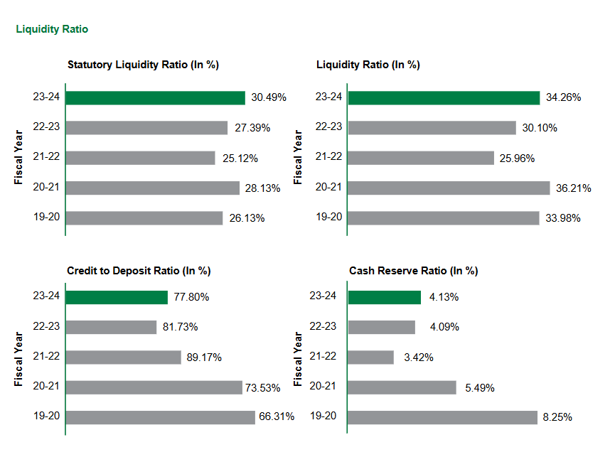Liquidity ratio measures the ability of a firm to meet its short-term obligations and reflects the short-term financial solvency of a firm sales factory liquidation position is one of the distinguishing characters of a sound banking system liquidity position of Agriculture Development Bank Ltd is analyzed using the following relevant liquidity ratio.

Figure: Liquidity Ratio

|  |  |  |
| --- | --- | --- |
| **Ratio Name** | **Formula** | **What it tells** |
| Current Ratio | CA/CL | Overall ability to pay short term debts |
| Quick Ratio | (CA-I)/CL | Stricter view, Excludes Inventory |
| Cash Ratio | (Cash + CE)-CL | Most conservative, - Only Cash |

**Key Findings**

**Statutory Liquidity Ratio (SLR)** The bank maintained statutory liquidity ratios above the regulatory minimum throughout the study period. The ratio fluctuated from 26.13% in 2019-20 to 30.49% in 2023-24, with the lowest point of 25.12% recorded in 2021-22. The recent improvement to 30.49% in 2023-24 indicates strengthened compliance with regulatory requirements.

**Liquidity Ratio** ADBL's liquidity ratio showed considerable variation, ranging from 25.96% in 2021-22 to 36.21% in 2020-21. The fiscal year 2023-24 recorded 34.26%, reflecting adequate liquid assets to meet immediate obligations. The declining trend in 2021-22 and 2022-23 suggests potential liquidity management challenges during this period.

**Credit to Deposit Ratio (CDR)** The bank's lending efficiency, measured by CDR, peaked at 89.17% in 2021-22, indicating aggressive lending policies. However, the ratio declined significantly to 77.80% in 2023-24, suggesting either reduced lending activities or increased deposit mobilization. This trend may reflect cautious lending practices or regulatory compliance adjustments.

**Cash Reserve Ratio (CRR)** The CRR maintained by ADBL varied from 3.42% in 2021-22 to 8.25% in 2019-20. The ratio of 4.13% in 2023-24 indicates compliance with central bank requirements while optimizing fund utilization for lending activities.

**Implications**

The liquidity ratios reveal ADBL's generally stable liquidity position with periodic fluctuations reflecting changing market conditions and regulatory adjustments. The recent improvements in SLR and overall liquidity ratios suggest enhanced financial stability and regulatory compliance.

### Analysis of Results

**Assets**

An asset is a resource or property having a monetary economic value possessed by an individual or entry, which is capable to generate some future economic benefits. Assets are generally brought in business to benefits from them and to increase the value of a business. In simple language, it means anything that a person ‘owns’ say a house or equipment. In the accounting context, an asset is a resource that can generate cash flow. The assets are recorded on the balance sheet. They are found on the right – hand side of the balance sheet and can also be referred to as ‘application of funds. The assets include furniture; machinery, account receivable, cash, investment. We shall discuss various types of assets in this article.

Assets are classified into different types based on their convertibility to cash; use in business or basis their physical existence. Assets are a part of the balance sheet and are stated at historical cost less depreciation deducted so far or at cost or at cost of market value, whichever is lower.

One way of classification of assets is based on their easy convertibility into cash.

According to this classification, total assets are classified either into Current Assets or Fixed Assets.

**Current Assets**

Assets that are easily convertible into cash like stock, inventory, marketable securities, short-term investments, fixed deposits, accrued incomes, bank balances, debtors, bills receivable, prepaid expenses etc. are classified as current assets. Current assets are generally of a shorter lifespan as compared to fixed assets which last for a longer period. Current assets can also be termed as liquid assets.

**Current Assets = Cash and Cash Equivalents + Accounts Receivable + Inventory + Short-Term Investments + Prepaid Expenses + Other Current Asset**

**Fixed Assets**

Fixed assets are of a fixed nature in the context that they are not readily convertible into cash. They require elaborate procedure and time for their sale and converted into cash. Land, building, plant, machinery, equipment, and furniture are some examples of fixed assets. Other names used for fixed assets are non-current assets, long-term assets or hard assets. Generally, the value of fixed assets generally reduces over a period of time (known as depreciation).

The objective of computing this ratio is to measure the ability of the firm to convert its current assets into cash or equivalent at a short notice so as to meet its current liabilities at shortest notice.

**Fixed Assets = Property + Plant + Equipment − Accumulated Depreciation**

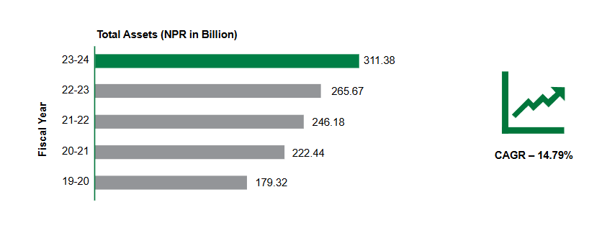

Figure : Total Assets

**Income**

The main source of income for any financial organization is definitely interest from investment. The source of interest income of Agricultural Development bank Ltd. for last five years van be shown in table and figure as following.

**Table No. 1**

**Interest Income**

|  |  |
| --- | --- |
| **Fiscal year** | **Interest Income (In millions)** |
| 2076/77 | 15821.701 |
| 2077/78 | 15124.046 |
| 2078/79 | 19582.603 |
| 2079/80 | 23948.684 |
| 2080/81 | 27142.121 |

**Source: Annual report of Agriculture Development Bank.**

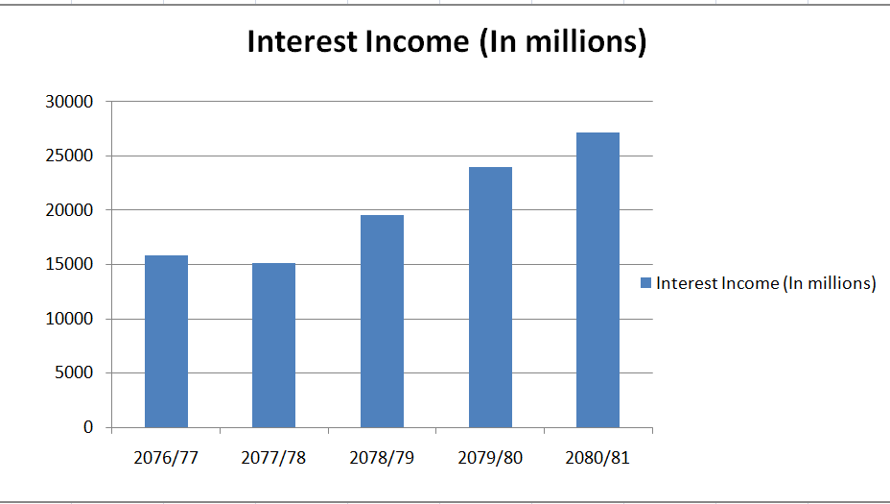**Figure 1**

Figure : Interest Income (In Millions)

In the above graph, last five fiscal years from 2076/77 to 2080/81 and amount of interest income are kept in horizontal and vertical axis respectively. Amount of interest income in different year seems to be increasing remarkably. The bank can generate revenue from the people who taken loan from the bank. In the last five years, the maximum amount of interest income earned in fiscal year 2080/81, it shows loan collection (loans recovery) from the takers are effectively carried out in Agriculture Development bank.

**Expenditure on Interest**

An interest expense is a non – operating expense shown on the income statement. It represents interest payable on any borrowings bond, loan, convertible debt or lines of credit. The expenses which Agriculture Development Bank Ltd. has expended for deposit loan and advance for last five year are as follows.

**Table No. 2**

**Interest Expense**

|  |  |
| --- | --- |
| **Fiscal year** | **Interest Expense (In millions)** |
| 2076/77 | 9105.579 |
| 2077/78 | 8258.328 |
| 2078/79 | 11226.663 |
| 2079/80 | 15753.025 |
| 2080/81 | 17016.384 |

**Source: Annual report of Agriculture Development Bank.**

**Figure 2**

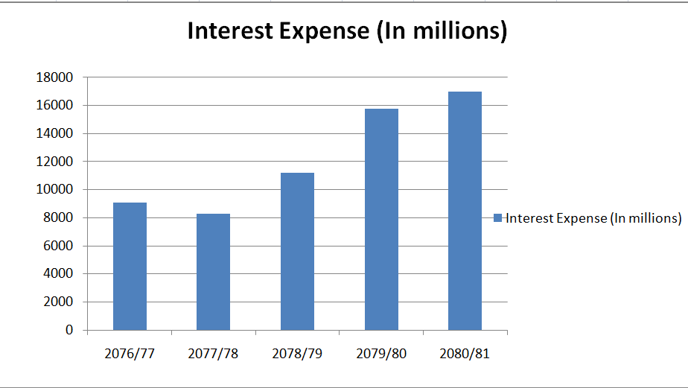

Figure : Interest Expense (In millions)

The above table and figure show the income expenses of last five years. From the above table, we find fiscal year 2077/78 has the lowest interest expenses among the other fiscal years and year 2080/81 has the highest interest expenses while comparing to others. It has shown that the growth in interest expenses is increasing each year. It shows that the bank is financially predicting good.

**Profitability Ratio**

Profitability ratios are a type of accounting ratio that helps in determining the financial performance of business at the end of an accounting period. Profitability ratios show how well a company is able to make profits from its operations. There are many measures of profitability. Higher degree of profitability ratio shows better financial position and performance to the firms.

**Net Profit Margin**

The net profit margin is equal to how much net income or profit is generated as a percentage of revenue. Net profit margin is a ratio of net profits to revenues for a company or business segment. Net profit margin is typically expressed as a percentage but can also be represented in decimal from. The net profit margin illustrates how much of each dollar in revenue collected by a company translates into profit.

Net income is also called the bottom line for a company or the net profit. Net profit margin is also called net margin.

**Net profit margin = Net income/Total operating income**

**Table No. 3**

**Net Profit Margin (in Million)**

|  |  |  |  |
| --- | --- | --- | --- |
| **Fiscal year** | **Net Income** | **Operating Profit** | **NPM** |
| 2076/77 | 8502.83 | 4318.60 | 1.968886 |
| 2077/78 | 9757.07 | 5037.32 | 1.936957 |
| 2078/79 | 8773.58 | 3604.41 | 2.434124 |
| 2079/80 | 8240.06 | 3136.56 | 2.627101 |
| 2080/81 | 9768.11 | 4138.86 | 2.360097 |

**Source: Annual report of Agriculture Development Bank.**

**Figure 3**

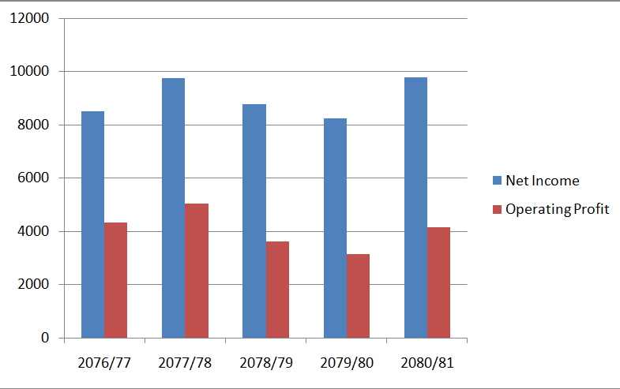

Figure 6: Net Profit Margin (in Million)

In the above figure 3, Net profit margin is arranged in Y- axis vertically and the fiscal year 2076/77 to 2080/81 is arranged horizontally in X- axis.

The above table and figure show the net profit margin of last five years. From the above table, we find fiscal year 2076/77 has the lowest Net profit margin among the other fiscal year and year 2079/80 has the highest Net profit margin while comparing to others.

**Return on Assets**

Return on assets (ROA) is an indicator of how profitable a company is relative to its total assets. ROA gives a manager, investor, or analyst an idea as to how efficient a company’s management is at using its assets to generate earnings. Return on assets is displayed as a percentage.

**The formula for ROA:**

**ROA= Net Income /Total assets**

**Table No. 4**

**Return on Assets (ROA) in Millions**

|  |  |  |  |
| --- | --- | --- | --- |
| **Fiscal year** | **Net Income** | **Total Assets** | **ROA (in %)** |
| 2076/77 | 8502.83 | 179320.858 | 4.741 |
| 2077/78 | 9757.07 | 222440.349 | 4.38 |
| 2078/79 | 8773.58 | 246184.242 | 3.563 |
| 2079/80 | 8240.06 | 265670.979 | 3.065 |
| 2080/81 | 9768.11 | 311375.43 | 3.13 |

**Source: Annual report of Agriculture Development Bank.**

**Figure 4**

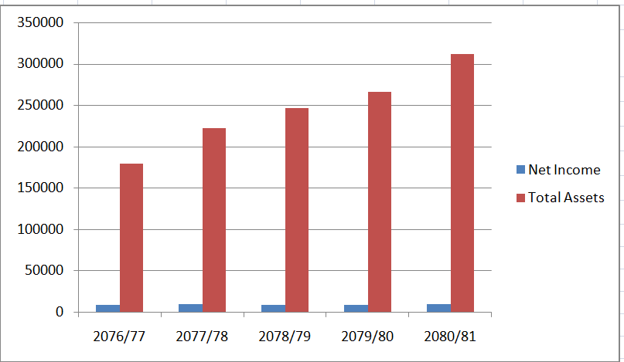

Figure : Return on Assets (ROA) in Millions

In above Table 4, shows the ROA in last five year i.e. 2076/77 to 2080/81. The ROA that been collected in last five years are 2076/77 is 4.741, 2077/78 is4.38, 2078/79 is 3.563, 2079/80 is 3.065, 2080/81 is 3.13 from the figure and table it is found that ROA is decreasing each year.

**Return on Equity (ROE)**

Return on equity (ROE) is the measure of a company’s net income divided by its shareholders equity. ROE is gauge of a corporation’s profitability and how efficiently it generates those profits. The higher the ROE, the better a company is at converting its equity financing into profits. The objective of computing this ratio is to determine how efficiently the funds supplied by shareholders have been used.

It is the relation between profit and shareholders’ equity.

**Table No. 5**

**Return on Equity (ROE)**

|  |  |  |  |
| --- | --- | --- | --- |
| **Fiscal year** | **Net Income** | **Shareholders’ Equity** | **ROE** |
| 2076/77 | 8502.83 | 28471.221 | 29.86 |
| 2077/78 | 9757.07 | 31505.117 | 30.96 |
| 2078/79 | 8773.58 | 33357.034 | 26.30 |
| 2079/80 | 8240.06 | 33793.653 | 32.85 |
| 2080/81 | 9768.11 | 36139.95 | 27.20 |

**Source: Annual report of Agriculture Development Bank.**

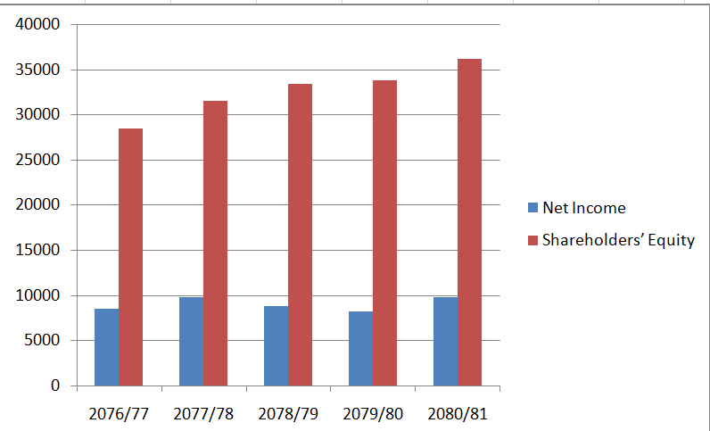**Figure 5**

Figure : Return on Equity (ROE)

In the above figure 5, ROE of last 5 years is arranged in Y-axis vertically and the fiscal year from 2076/77 to 2080/81 are arranged horizontally in X-axis.

the above table, we find fiscal year 2078/79 has the lowest ROE among the other fiscal year and 2079/80 has the highest ROE while comparing to other.

**Earnings per share**

EPS measures how much profit is allocated to each share of a company’s stock. It shows the company’s profitability on a per-share basis. Higher EPS indicates higher profitability per share and is attractive to investors.

**Table No. 6**

**Earnings Per Share (EPS)**

|  |  |
| --- | --- |
| **Fiscal year** | **EPS** |
| 2076/77 | 27.35 |
| 2077/78 | 24.28 |
| 2078/79 | 14.41 |
| 2079/80 | 7.42 |
| 2080/81 | 19.12 |

**Source: Annual report of Agriculture Development Bank.**

**Figure 6**

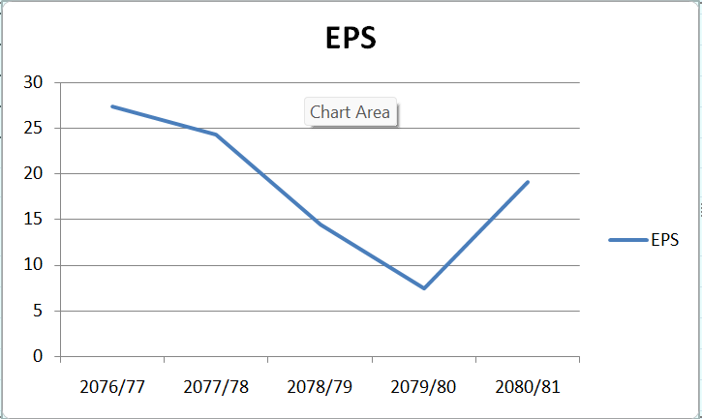

Figure 9: Earnings Per Share (EPS)

In above figure 6, EPS is arranged in Y- axis vertically and the fiscal year from 2076/77 to 2080/81 are arranged horizontally in X-axis.

The above table and figure show the EPS of the last five fiscal years. From the above table, we find fiscal year 2079/80 has lowest EPS among the other fiscal year and 2076/77 has the highest EPS while comparing to other.

**Price –To-Earnings Ratio**

The P/E Ratio shows how much investor is willing to pay for one rupee of earning. It compares a company’s market price per share to its earnings per share.

A high P/E may mean the company is overvalued or expected to grow fast

**Table No. 7**

**Price to Earnings Ratio (PE Ratio)**

|  |  |
| --- | --- |
| **Fiscal year** | **PE Ratio** |
| 2076/77 | 12.24 |
| 2077/78 | 16.44 |
| 2078/79 | 22.98 |
| 2079/80 | 31.54 |
| 2080/81 | 15.38 |

**Source: Annual report of Agriculture Development Bank.**

**Figure 7**

Figure : Price to Earnings Ratio (PE Ratio)

### Findings

The financial analysis of Agricultural Development Bank Limited over five years (2076/77 to 2080/81) reveals mixed performance with significant concerns about operational efficiency despite stable liquidity management. The study employs key financial ratios and statistical measures to evaluate the bank's performance against theoretical banking principles.

Liquidity analysis shows ADBL maintained adequate liquid assets throughout the study period. The Statutory Liquidity Ratio fluctuated between 25.12% and 30.49%, consistently above regulatory minimums with a coefficient of variation of 7.89% (CV = Standard Deviation/Mean × 100), indicating stable liquidity management. The Credit-to-Deposit Ratio peaked at 89.17% in 2078/79 but declined to 77.80% in 2080/81, suggesting either cautious lending or improved deposit mobilization. This aligns with Commercial Loan Theory, which emphasizes balancing liquidity with lending opportunities.

The most concerning finding is the deteriorating profitability performance. Return on Assets declined from 4.741% to 3.13%, representing a 33.97% decrease using the trend formula: (Final Value - Initial Value)/Initial Value × 100. This decline indicates poor asset utilization efficiency, contradicting fundamental banking principles of maximizing asset returns. The ROA formula (ROA = Net Income/Total Assets) shows that despite growing assets, the bank's income generation capability weakened significantly.

Return on Equity showed high volatility, ranging from 26.30% to 32.85% with a coefficient of variation of 9.75%. Using DuPont Analysis (ROE = ROA × Equity Multiplier), the declining ROE primarily results from deteriorating ROA rather than capital structure issues. This suggests operational inefficiency rather than inadequate capitalization.

Earnings Per Share exhibited extreme volatility, declining from Rs. 27.35 to Rs. 7.42 before recovering to Rs. 19.12. The coefficient of variation for EPS was 44.63%, indicating highly unstable earnings that would concern investors. The EPS formula (EPS = Net Income/Outstanding Shares) reveals inconsistent profit distribution to shareholders.

Net Profit Margin improved from 1.97% to 2.36%, showing a 19.80% growth rate. The formula NPM = Net Income/Total Revenue indicates better cost control relative to income generation. However, this positive trend contrasts sharply with declining ROA, suggesting that while the bank improved operational efficiency, it failed to effectively utilize its expanding asset base.

Interest income analysis reveals strong revenue growth with an 11.36% Compound Annual Growth Rate (CAGR = [(Final Value/Initial Value)^(1/n)] - 1). Interest income grew from Rs. 15,821.70 million to Rs. 27,142.12 million, demonstrating market expansion capability. However, interest expenses grew faster at 13.34% CAGR, from Rs. 9,105.58 million to Rs. 17,016.38 million. This creates margin compression, as expenses outpaced income growth by 1.98 percentage points.

The correlation between interest income and expenses was 0.89, confirming Interest Rate Risk Theory that both move together with market conditions. The faster expense growth indicates the bank paid higher rates for deposits than it earned on loans, suggesting competitive pressure or poor asset-liability management.

Statistical risk assessment using Z-Score Model components indicates moderate financial risk. While the bank maintains regulatory compliance and adequate liquidity, declining asset efficiency and earnings volatility suggest underlying operational challenges.

The analysis reveals that ADBL faces the classic dilemma of development banks balancing social objectives with commercial viability. The declining asset turnover (implied from ROA and NPM trends) suggests the bank may hold assets serving developmental purposes that generate suboptimal commercial returns.

Key recommendations include improving asset utilization through portfolio optimization, controlling interest expense growth to maintain spreads, and implementing measures to reduce earnings volatility. The bank should focus on enhancing asset turnover while maintaining its developmental mandate, as sustainable profitability **ensures long-term capacity to serve agricultural development objectives.**

**Major Statistical Findings:**

1. **ROA Decline**: The most concerning finding is the 33.97% decline in Return on Assets from 4.741% to 3.13%, indicating deteriorating asset utilization efficiency.
2. **Interest Income Growth**: Strong 11.36% compound annual growth rate in interest income, demonstrating good revenue generation capability.
3. **EPS Volatility**: Extremely high coefficient of variation (44.63%) for Earnings Per Share, indicating unstable earnings performance.
4. **Liquidity Stability**: SLR maintained above regulatory requirements with a low coefficient of variation (7.89%), showing stable liquidity management.

### CHAPTER III

### SUMMARY AND CONCLUSIONS

### Summary

This study examined the financial performance of Agricultural Development Bank Limited (ADBL) over five years from 2076/77 to 2080/81. The main purpose was to understand how well the bank is performing financially and whether it can continue to serve farmers and rural communities effectively.

The research used financial ratios and statistical tools to analyze the bank's annual reports. Key areas studied included how easily the bank can pay its short-term debts, how profitable it is, and how well it manages its money and assets.

The findings show mixed results. On the positive side, ADBL has maintained good cash flow and can easily meet its immediate payment obligations. The bank has also grown its income significantly, earning more money from loans and investments each year. Interest income increased by about 11% annually, showing the bank is expanding its business.

However, there are serious concerns about efficiency. The bank's ability to generate profit from its assets dropped by 34% over the study period. This means the bank is not using its resources as effectively as before. Earnings per share became very unstable, sometimes high and sometimes very low, which makes investors worried about putting money in the bank.

The bank's expenses are also growing faster than its income. While income grew by 11% per year, expenses grew by 13% per year. This squeeze on profits makes it harder for the bank to remain financially healthy in the long run.

Overall, while ADBL remains stable and continues to serve its customers, it faces challenges in managing its resources efficiently and controlling costs. The bank needs to improve how it uses its assets and controls expenses to ensure it can continue supporting Nepal's agricultural sector effectively.

### Conclusion

The comprehensive financial analysis of Agricultural Development Bank Limited reveals a complex picture of an institution struggling to balance its social mission with commercial sustainability. After carefully examining five years of financial data, several important conclusions emerge that have significant implications for the bank's future and its role in Nepal's agricultural development.

First and most importantly, ADBL faces a fundamental efficiency problem. The bank's Return on Assets declined dramatically from 4.74% to 3.13%, which means the bank is getting less profit from every rupee it invests. This is like having a shop where you invest more money in inventory but sell less relative to what you invested. For a bank, this is particularly concerning because it suggests management is not making good decisions about where to put the bank's money. When banks cannot generate adequate returns from their assets, they struggle to pay depositors competitive interest rates and may eventually face financial difficulties.

The earnings instability represents another major concern. Earnings per share fluctuated wildly from Rs. 27 to Rs. 7 and back to Rs. 19, showing the bank's profits are unpredictable. This is problematic because banks need steady earnings to build reserves for bad times and to maintain depositor confidence. When earnings jump around too much, it suggests the bank's business model is not stable, which can scare away both depositors and investors.

However, the bank demonstrates strong revenue generation capabilities. Interest income grew consistently at 11% annually, proving that ADBL can attract borrowers and expand its lending business. This growth shows there is demand for the bank's services and that it operates in a growing market. The agricultural sector in Nepal continues to need financing, and ADBL has successfully positioned itself to capture this market.

The margin compression issue, where expenses grow faster than income, reflects the competitive pressure in Nepal's banking sector. When expenses grow at 13% while income grows at 11%, it creates a squeeze that gradually reduces profitability. This often happens when banks face competition for deposits, forcing them to pay higher interest rates to depositors while struggling to charge higher rates to borrowers. ADBL must find ways to control costs or improve pricing to address this challenge.

The bank's liquidity management deserves recognition as a strength. Maintaining adequate cash reserves while meeting regulatory requirements shows professional management of short-term obligations. This is crucial for maintaining depositor confidence and regulatory compliance, especially for a bank serving rural communities where trust is essential.

The dual nature of ADBL as both a commercial bank and development institution creates unique challenges. Unlike purely commercial banks that can focus solely on profit maximization, ADBL must serve farmers and rural entrepreneurs who may represent higher risks or lower returns. This social mandate means the bank sometimes makes loans or investments that serve development goals rather than pure profit motives. While this is important for Nepal's agricultural development, it can explain some of the efficiency concerns identified in the analysis.

Looking forward, ADBL must address several critical areas. Asset utilization needs immediate attention through better loan portfolio management and more selective lending practices. The bank should focus on loans that generate good returns while still serving its development mission. Cost control measures are essential to stop the expense growth from outpacing income growth. This might involve streamlining operations, improving technology, or renegotiating supplier contracts.

The earnings volatility issue requires attention to business model stability. ADBL should diversify income sources beyond traditional lending, perhaps through fee-based services or agricultural value chain financing. Building more predictable revenue streams will help stabilize earnings and improve investor confidence.

Despite these challenges, ADBL remains fundamentally important to Nepal's economy. Agricultural development banks play crucial roles in rural economies, providing credit and financial services that commercial banks often avoid. The bank's continued growth in lending and customer base shows it fulfills a real need in the market.

The conclusion is that ADBL stands at a crossroads. With proper management attention to efficiency, cost control, and strategic focus, the bank can continue serving Nepal's agricultural sector while improving financial performance. However, without addressing the identified issues, the bank risks becoming less effective at both its commercial and developmental objectives, potentially reducing its ability to support Nepal's rural economy in the long term.

### BIBLIOGRAPHY

Annual Report of Agricultural Development Bank Ltd.

Adhikari, D.R. & Pandey, D.L., (2067), AnusadhanPaddati, Kathmandu Sunrise Publications (P) Ltd.

Atrill, P., & McLaney, E. (2016). *Accounting and Finance for Non-Specialists* (10th ed.). Pearson Education.

Bhattarai, K. R. (2016). Financial Performance Evaluation of Nepalese Commercial Banks. Kathmandu: Asmita Publications.

Brigham, E. F., & Houston, J. F. (2019). *Fundamentals of Financial Management* (15th ed.). Cengage Learning.

Brigham, E. F., & Houston, J. F. (2021). *Fundamentals of Financial Management* (15th ed.). Boston: Cengage Learning.

Damodaran, A. (2010). *Applied Corporate Finance* (3rd ed.). Wiley.

Fabozzi, F. J. (2009). *Financial Management and Analysis* (2nd ed.). Hoboken: Wiley.

Gautam, T.R. (2066 B.S.), Social Research Methodology (6th ed). Kathmandu Vidyarthi Pustak Bhandar

Gibson, C. H. (2009). *Financial Reporting and Analysis* (12th ed.). Cengage Learning.

Gitman, L. J. (2018). *Principles of Managerial Finance* (14th ed.). Boston: Pearson.

Horngren, C. T., Sundem, G. L., & Elliott, J. A. (2009). *Introduction to Financial Accounting* (9th ed.). New Jersey: Prentice Hall.

Jensen, M. C., & Meckling, W. H. (1976). Theory of the firm: Managerial behavior, agency costs, and ownership structure. *Journal of Financial Economics*, 3(4), 305–360.

Joshi, M. (2020). A Study on Profitability Ratios of Nepalese Banks. Kathmandu: Sagarmatha Press.

Kaplan, R. S., & Norton, D. P. (1996). *The Balanced Scorecard: Translating Strategy into Action*. Harvard Business Press.

Koirala, S. (2018). Liquidity Management in Nepalese Commercial Banks. Lalitpur: Buddha Academic Enterprises.

Kothari, C. R. (2004). *Research Methodology: Methods and Techniques* (2nd ed.). New Delhi: New Age International Publishers.

Mishkin, F. S., & Eakins, S. G. (2018). *Financial Markets and Institutions* (9th ed.). Boston: Pearson.

Pandey, D.L. (2067 B.S.), Effect of training on organizational performance in the service of sector of Nepal. The Management Review, 15:7, 149-761

Pandey, I. M. (2021). *Financial Management* (12th ed.). Vikas Publishing.

Reilly, F. K., & Brown, K. C. (2011). *Investment Analysis and Portfolio Management* (10th ed.). Mason: Cengage Learning.

Ross, S. A., Westerfield, R. W., & Jordan, B. D. (2018). *Essentials of Corporate Finance* (9th ed.). McGraw-Hill Education.

|  |  |
| --- | --- |
|  |  |

Rose, P. S., & Hudgins, S. C. (2013). *Bank Management & Financial Services* (9th ed.). New York: McGraw-Hill.

Ross, S. A., Westerfield, R. W., & Jordan, B. D. (2019). *Essentials of Corporate Finance* (9th ed.). New York: McGraw-Hill Education.

Shrestha, P. (2016). Capital Adequacy and Profitability of Nepalese Commercial Banks. Lalitpur: Sagun Prakashan.

Shrestha, Rubika (2072), 'A case study on loan providing system of Agricultural Development Bank Ltd'

Subedi, D. (2022). Comparative Study of Financial Performance in Class 'A' Banks of Nepal. Bhaktapur: Ratna Publication.

Weston, J. F., & Brigham, E. F. (2005). *Managerial Finance*. New York: Dryden Press.

White, G. I., Sondhi, A. C., & Fried, D. (2003). *The Analysis and Use of Financial Statements* (3rd ed.). New York: Wiley.

Wild, J. J., Subramanyam, K. R., & Halsey, R. F. (2014). *Financial Statement Analysis* (11th ed.). McGraw-Hill Education.

### Appendix

Source: Annual report of Agriculture Development Bank.



